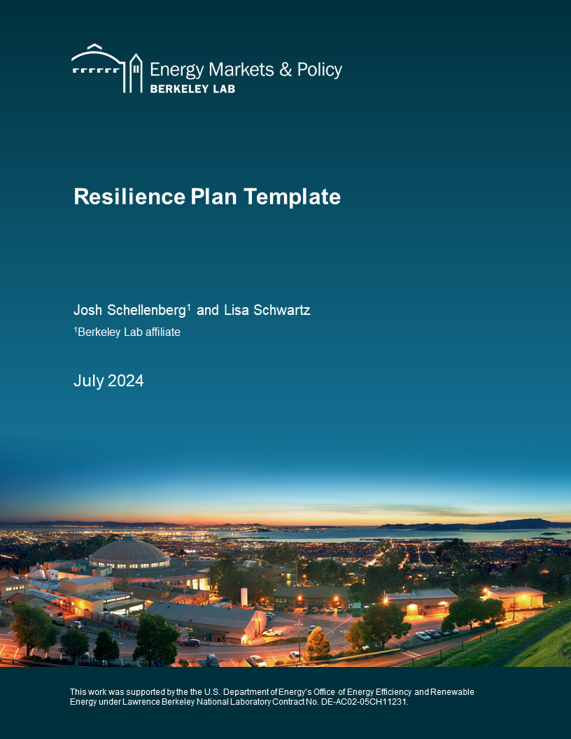

**Disclaimer**

This document was prepared as an account of work sponsored by the United States Government. While this document is believed to contain correct information, neither the United States Government nor any agency thereof, nor The Regents of the University of California, nor any of their employees, makes any warranty, express or implied, or assumes any legal responsibility for the accuracy, completeness, or usefulness of any information, apparatus, product, or process disclosed, or represents that its use would not infringe privately owned rights. Reference herein to any specific commercial product, process, or service by its trade name, trademark, manufacturer, or otherwise, does not necessarily constitute or imply its endorsement, recommendation, or favoring by the United States Government or any agency thereof, or The Regents of the University of California. The views and opinions of authors expressed herein do not necessarily state or reflect those of the United States Government or any agency thereof, or The Regents of the University of California.

Ernest Orlando Lawrence Berkeley National Laboratory is an equal opportunity employer.

**Copyright Notice**

This manuscript has been authored by an author at Lawrence Berkeley National Laboratory under Contract No. DE-AC02-05CH11231 with the U.S. Department of Energy. The U.S. Government retains, and the publisher, by accepting the article for publication, acknowledges, that the U.S. Government retains a non-exclusive, paid-up, irrevocable, worldwide license to publish or reproduce the published form of this manuscript, or allow others to do so, for U.S. Government purposes.

Prepared for the

Office of Energy Efficiency and Renewable Energy

U.S. Department of Energy

Authors

Josh Schellenberg

Lisa Schwartz

Ernest Orlando Lawrence Berkeley National Laboratory

1 Cyclotron Road, MS 90R4000

Berkeley CA 94720-8136

July 2024

# 

# Resilience Plan Template

*States and utilities can adapt this template to account for jurisdiction-specific considerations. A Word document version is available on* [*Berkeley Lab's website*](https://emp.lbl.gov/publications/grid-resilience-plans-state) *for this purpose.*

**Section 1. Executive Summary**

* Resilience plan objectives and motivation
  + Legislative and regulatory requirements
  + Extreme weather events, increasing restoration costs, availability of government funding support, data sources and solutions, technological changes, and other jurisdiction-specific items
* Definition of resilience, resilience event, and reliability – for example:
  + *Resilience* – “[A]bility to prepare for and adapt to changing conditions and withstand and recover rapidly from disruptions. Resilience includes the ability to withstand and recover from deliberate attacks, accidents, or naturally occurring threats or incidents.”[1]
  + *Resilience event* – “[A]n event involving extreme weather conditions, wildfires, cybersecurity threats, or physical security threats that poses a material risk to the safe and reliable operation of an electric utility’s transmission and distribution systems. A resiliency event is not primarily associated with resource adequacy or an electric utility’s ability to deliver power to load under normal operating conditions.”[2]
  + *Reliability* – “The ability to maintain the delivery of electric power to customers in the face of routine uncertainty in operating conditions.”[3]
* Definitions of other key terms,[4] including those that define what the plan does (and does not) cover in terms of the service territory, infrastructure areas, etc.
* Hazards in scope
  + Summary of all hazards considered and ultimately selected during plan development
  + Brief rationale for any hazards that were not included in the vulnerability assessment
* Summary progress report on programs included in the most recently filed resilience plan (if appliable) to clearly communicate advancement or completion of:
  + Resilience program delivery
  + Changes in key performance metrics, particularly during any resilience events
  + Progress toward mitigation of specific vulnerabilities for the applicable utility infrastructure and processes
* Summary of measures considered and ultimately selected during plan development to enhance resilience of the utility’s infrastructure and processes,[5] including:
  + Hardening electrical transmission and distribution (T&D) facilities
  + Modernizing electrical T&D facilities
  + Undergrounding certain electrical distribution lines
  + Lightning mitigation measures
  + Flood mitigation measures
  + Information technology (IT)
  + Cybersecurity measures
  + Physical security measures
  + Vegetation management
  + Wildfire mitigation and response
  + Emergency planning and response
  + Design criteria and standards
  + Other eligible resilience measures
* Proposed resilience programs in plan
  + Name of each resilience program[6]
  + Category of resilience measure(s) (from list of measure types above)
  + How program is expected to mitigate impacts for identified vulnerabilities in utility infrastructure and/or processes for specific hazard(s), including high winds, wildfires, floods, freezes, heat waves, cyber and physical security threats, and other hazards
* Summary of overall costs and benefits by resilience program, including:
  + Cost summary
  + Rate impacts
  + Expected benefit streams (such as reduced restoration costs, shorter outage duration, avoided resilience events, lower unserved energy, avoided customer interruption costs and increased safety)
  + Summary of quantitative and qualitative benefits[7]
  + How the program prioritizes vulnerable populations, critical infrastructure and worst-performing circuits during resilience events
* Summary of performance metrics
  + Description of metrics the utility plans to use to report on the plan’s progress and performance
  + Underlying assumptions for calculating metrics
  + Expected performance results by category of resilience event severity (such as storm category levels based on wind speeds for extreme weather)
* Description of how the utility’s resilience plan aligns with the State Energy Security Plan under the federal Infrastructure Investment and Jobs Act (IIJA)
* Summary of how the resilience plan fits into other utility planning processes, including transmission and distribution plans, transportation and building electrification plans, and climate vulnerability and adaptation plans, as well as local government infrastructure plans and emergency response plans
* Status of applications and approvals for state and federal resilience funding support
* Summary of how the overall resilience plan serves the public interest

**Section 2. Vulnerability Assessment**[8]

* Description of utility service territory
* History of resilience events in the service territory in the past five to 10 years, including storms, wildfires, floods, freezes, heat waves, cyber and physical security incidents, seismic events, and other hazards[9] (include estimated restoration costs and times and, if available, customer interruption costs)
* Summary of approach for projecting frequency and severity of resilience events (include detailed analysis methodology in an appendix)
  + Methodology for projecting resilience events at a granular geographic level in the service territory to identify specific areas and infrastructure vulnerable to each type of hazard, factoring in how frequency and severity of extreme weather will be different from prior years due to climate change (recommended approach)[10]
  + Alignment of projections with analysis conducted or sponsored by the state (if available)
  + Climate scenarios considered, including scenarios with compounding of extreme event impacts (such as high winds and flooding)[11]
  + If the projections assume that the frequency and severity of extreme weather will remain similar to prior years (not recommended), provide the specific time period, with a preference for more recent years, and extreme weather events analyzed (including weighting of years and events in the projections, if not a simple average)
* Summary of community and stakeholder engagement
  + How the plan’s priorities considered the viewpoints expressed by key stakeholders
  + For extreme weather hazards,[12] provide summary of the stakeholder engagement process to date, including local communities, vulnerable populations, critical and essential facilities, and government entities, most notably emergency responders
  + Outcomes and changes in plan based on stakeholder engagement process
  + Future stakeholder engagement included in resilience plan
* Vulnerabilities and their impact on customers and communities
  + How the plan incorporates criteria for critical and essential facilities[13] and vulnerable populations (including method employed — e.g., state guidance, maps or data, community engagement, worst-performing circuits during prior resilience events)
  + Methodology for identifying utility infrastructure and processes that are highly vulnerable to resilience events
  + Matrix that summarizes all hazards relative to infrastructure and process areas, analyzed with a clearly defined vulnerability rating[14] that applies to each infrastructure-hazard and process-hazard pair (see example matrix in Table I)
  + Estimated economic impacts (adverse consequences), including utility, customer and societal costs, if a resilience event were to occur and expose a vulnerability
  + Projections of economic impacts that result from extreme weather events, or cyber or physical security incidents, weighted by the likelihood that a resilience event occurs during the planning horizon
  + Any areas where the utility has determined that enhancement of its existing infrastructure and processes would not be feasible, reasonable or practical at this time
  + Appendix with more detailed results of the vulnerability assessment, including how projections of frequency and severity of resilience events inform prioritization of which vulnerabilities are most important to mitigate through a resilience program

Table I. Example Vulnerability Matrix*

|  |  |  |  |  |
| --- | --- | --- | --- | --- |
| **Category of Utility Infrastructure or Processes** | **Hazards Included in Vulnerability Assessment (Vulnerability Rating)** | | | |
| High Winds | Floods | Heat Waves | Cybersecurity |
| Substations |  |  |  |  |
| Transmission lines |  |  |  |  |
| Transmission towers |  |  |  |  |
| Distribution lines |  |  |  |  |
| Distribution poles |  |  |  |  |
| Distribution transformers |  |  |  |  |
| Key company facilities |  |  |  |  |
| Asset management |  |  |  |  |
| Load forecasting |  |  |  |  |
| Workforce safety |  |  |  |  |
| Emergency response |  |  |  |  |
| Vegetation management |  |  |  |  |

* Add rows and columns as needed.

**Section 3. Description of Each Proposed Resilience Program**

* Proposed resilience programs, including:
  + Time period (actual or estimated start and completion dates)[15]
  + Cost estimate, including capital and operating and maintenance (O&M) expenses broken down by the projects and resilience measures within the program
  + Vulnerabilities in utility infrastructure or processes for a specific hazard that the program is designed to mitigate
  + How each resilience measure within the program is targeted based on system, climate, geographic or community characteristics[16]
  + Description of how the program impacts the prevention of, response to and recovery from resilience events
  + Expected improvement to utility’s existing infrastructure and processes[17]
* Rationale for selecting and prioritizing the proposed program, including the following:
  + Description of the affected utility infrastructure and processes and specific vulnerability mitigated
  + Alternatives considered for mitigating the vulnerability, including results of prioritization analyses that compared different options
  + Number and type(s) of customers impacted by the program
  + Expected performance improvement under varying severities of extreme weather conditions (or under cyber or physical security threats or seismic events, if applicable)
  + How the utility used stakeholder input and projections of performance during resilience events to prioritize the proposed program
  + How the program prioritizes areas of lower historical performance
  + Options considered to mitigate resulting rate impacts, including:
    - State and federal funding support
    - Cost efficiencies by aligning program with capital upgrades and O&M in the utility’s distribution plan and other applicable plans
    - Coordination with local municipalities that plan to mitigate certain vulnerabilities to extreme weather hazards (such as investments in flood management)
* Estimated benefits,[18] including but not limited to:
  + Reduced restoration costs (to restore power and replace damaged equipment)
  + Shorter outage duration
  + Avoided resilience events
  + Lower unserved energy
  + Avoided customer interruption costs
  + Increased safety during extreme weather conditions (or under cyber or physical security threats, if applicable)
  + Comparison of costs and benefits for the proposed resilience program
* Performance metrics
  + Description of metrics the utility plans to use to evaluate the program’s performance
  + Assumptions that underlie the use of those metrics
  + Scope of reporting on progress of program implementation and effectiveness

**Section 4. Projected Costs and Rate Impacts**

* Estimated number and cost of projects under each specific program
* Reconciliation that summarizes how each program is incremental to other resilience-related investments that the utility has proposed, planned, and implemented as part of a General Rate Case or other planning process
* Cost drivers for each program, such as:
  + Frequency of inspections (T&D assets)
  + Frequency of trim cycles (vegetation management)
  + Projected miles of affected T&D lines
  + Estimated annual labor and equipment costs for both utility and contractor personnel
* Estimated annual revenue requirements for each year of the plan (Table II)

Table II. Estimated Annual Revenue Requirements by Year

|  |  |
| --- | --- |
| **Year** | **Resilience Plan Annual Revenue Requirement  ($ millions)** |
|
| 2024 |  |
| 2025 |  |
| 2026 |  |
| 2027 |  |
| 2028 |  |
| 2029 |  |
| … |  |

* Estimated impacts for each year of the plan
* Estimated rate impacts for each of the first three years of the plan for the utility’s average residential, commercial and industrial customer (Table III)

Table III. Estimated Rate Impacts by Customer Class (years 1-3 of resilience plan)

|  |  |  |  |
| --- | --- | --- | --- |
| **Customer Class** | **Estimated Rate Impacts** | | |
| 2024 | 2025 | 2026 |
| Residential ($/kWh) |  |  |  |
| Commercial ($/kW and $/kWh) |  |  |  |
| Industrial ($/kW and $/kWh) |  |  |  |

1. [Presidential Policy Directive](https://obamawhitehouse.archives.gov/the-press-office/2013/02/12/presidential-policy-directive-critical-infrastructure-security-and-resil) (2013)
2. This illustrative definition is from [Texas](https://interchange.puc.texas.gov/Documents/55250_43_1360196.PDF), based on hazards in scope in that state. The electricity industry does not have a standard definition for “resilience event.” Each jurisdiction develops its own definition based on hazards in scope. The definition may indicate the range of normal operating conditions as well as the degrees of severity for resilience events.
3. Eto et al. (2020). Other definitions of reliability may simply refer to “normal operating conditions,” as in the resilience event definition.
4. The [IPCC Glossary](https://apps.ipcc.ch/glossary/) provides generally accepted definitions for many key terms, including risk, hazard (similar to threat), vulnerability, impacts (similar to consequence), exposure, sensitivity and adaptive capacity.
5. While the focus of many resilience plans is the T&D system, utilities may consider measures that improve resilience under bulk system emergency alerts and fuel supply shortages, such as IT investments to optimize load shedding, improve energy efficiency (PNNL et al. 2023), and control microgrids and distributed energy resources (PNNL 2022).
6. For example, Florida Power & Light (2022) calls resilience programs the “Distribution Inspection Program,” “Transmission Hardening Program,” “Substation Storm Surge/Flood Mitigation Program,” etc.
7. Planners can use Berkeley Lab’s [Power Outage Economics Tool](https://emp.lbl.gov/publications/power-outage-economics-tool-prototype) (POET) to estimate the impacts of longer duration and consecutive outages. However, a study would need to be conducted to provide the necessary data to use the tool.
8. For examples of in-depth vulnerability and hazard assessment approaches, see Con Edison’s Climate Change Vulnerability Study (2023a), Southern California Edison’s Climate Change Vulnerability Assessment (2022), and PG&E’s wildfire mitigation plan (2024).
9. Depending on the jurisdiction-specific definition of “resilience event.”
10. Argonne National Laboratory developed a tool called the [Climate Risk and Resilience Portal](https://climrr.anl.gov/) (ClimRR) that utilities can use to support development of local climate projections. Also see PNNL (2023) for a review of emerging best practices for projecting extreme weather events at a granular geographic level.
11. Resilience plans may use two or more scenarios to assess the range of potential impacts under varying frequencies and severities of resilience events. With this information, utilities can identify “no regrets” measures that are cost-effective under all scenarios, in addition to measures that may only be cost-effective under a worst-case scenario.
12. For cyber and physical security threats, the plan can summarize any independent third-party review and standards employed – for example, see NERC (2015). This step may take place later in the plan development process.
13. FEMA defines "critical facilities" as structures from which essential services and functions for victim survival, continuation of public safety actions, and disaster recovery are performed or provided. Shelters, emergency operation centers, public health, public drinking water, and sewer and wastewater facilities are examples of critical facilities. “Essential facilities” may include certain grocery stores, community centers, or other facilities that the community deems are particularly important to access during a resilience event.
14. The vulnerability rating typically accounts for exposure, sensitivity and adaptive capacity. [IPCC](https://apps.ipcc.ch/glossary/) defines sensitivity as “The degree to which a system or species is affected, either adversely or beneficially, by climate variability or change.” The IPCC defines adaptive capacity as “The ability of systems, institutions, humans and other organisms to adjust to potential damage, to take advantage of opportunities or to respond to consequences.” See [IPCC Glossary](https://apps.ipcc.ch/glossary/). When combined with exposure of a community, asset, critical infrastructure facility, service or process to a specific hazard, the vulnerability assessment and associated rating follow a common framework that many utilities and government agencies have used for resilience plans (including for electric, water and gas systems) and other infrastructure, processes and services.
15. This section may include programs that are designed to mitigate longer term vulnerabilities, but are not included in the budget for the current plan, given the planning horizon or other factors.
16. For example, consider a program designed to mitigate vulnerability of transmission lines to wildfires. A program that proposes undergrounding all transmission lines may be less cost-effective than a program that also considers measures such as enhanced inspections and vegetation management. Targeting each resilience measure based on system, geographic or community characteristics can increase cost-effectiveness.
17. While the plan focuses on improving performance during resilience events, many programs also may deliver reliability improvements under normal operating conditions. These types of “co-benefits” are important to consider.
18. For a comprehensive analysis framework to estimate costs and benefits of undergrounding T&D lines, see Larsen (2016). Sandia’s ReNCAT tool applies a benefit-cost analysis framework for microgrids (Sandia National Laboratories 2023).