Design and Operating Principles for High-Performing Anion Exchange Membrane Water Electrolyzers

Andrew W. Tricker1, Jason K. Lee1, Jason R. Shin1,2, Nemanja Danilovic1, Adam Z. Weber1, Xiong Peng1*

1Energy Storage and Distributed Resources Division, Lawrence Berkeley National Laboratory, Berkeley, CA 94720, USA

2Department of Chemical Engineering, University of California Berkeley, Berkeley, CA 94720, USA

AUTHOR INFORMATION

Corresponding Author

*Xiong Peng: [xiongp@lbl.gov](mailto:xiongp@lbl.gov)

**ABSTRACT**

Anion-exchange-membrane water electrolyzers (AEMWEs) provide a promising pathway to utilize low-carbon renewable electricity to produce clean hydrogen at high efficiency and purity, while maintaining low system costs compared to incumbent technologies. Though significant progress has been made in developing membranes and catalysts, AEMWEs still require better performance and durability to realize widespread deployment. Here, we overcome these challenges by decoupling anode and cathode polarization behavior via integration of a reference electrode in the membrane-electrode assembly. This measurement identified that the mass-transport losses dominate the cathode overpotential if feeding with electrolytes, while kinetic losses dominate the anode overpotential. These losses are mitigated by varying electrode properties and operating strategies, where a more hydrophobic, optimal loaded cathode, a high porosity anode, and operating with the cathode dry exhibited the best performance. These findings eventually enabled achieving a high-performing and durable complete PGM-free AEMWE operating at 1.5 A cm-2 for over 500 h with negligible degradation, demonstrating significant progress for AEMWEs.

**1. Introduction**

A growing demand for more sustainable ways of utilizing energy and mitigating the global threats of climate change necessitates developing alternative energy carriers and industrial feedstocks. Hydrogen produced via water electrolysis can play a significant role in sectors that are not easily adapted to direct decarbonization with renewable electrons. These hard-to-decarbonize sectors include heavy-duty transportation and industrial processes. For long-haul freight transportation, electrification using batteries is difficult due to the weight penalty needed to achieve necessary power and range, whereas hydrogen fuel cells avoid this issue by decoupling power generation and energy storage.1 Electrolytic hydrogen can replace carbon monoxide to reduce iron oxide chemically during steel production, and allow water to displace methane as the hydrogen source in ammonia production during fertilizer production.2 As such, to achieve net zero carbon emissions, the worldwide demand for hydrogen is projected to increase from 90 million tonnes per annum (Mtpa) in 2020 to over 500 Mtpa by 2050.3 To fill this demand, low-cost and efficient electrolyzers that are compatible with intermittent renewable electricity need be developed to produce hydrogen at global scales.

Electrolytic hydrogen was first commercialized in the early twentieth century with the development of liquid alkaline water electrolyzers (LAWEs), utilizing nickel electrodes and hot (80~90 ℃) concentrated KOH electrolyte (~30 wt%).4 However, large internal resistances and subsequent low operational efficiencies have limited LAWE to producing less than 0.1% of the current global hydrogen supply.3 Besides, traditional LAWEs are designed to run under continuous, steady operating conditions, which poses challenges when tethered to intermittent renewable electricity to produce low-carbon hydrogen. With the development of perfluorinated sulfonic-acid (PFSA) polymer electrolytes in the 1970s, proton-exchange-membrane water electrolyzers (PEMWEs) were developed as an efficient alternative to LAWEs which could generate higher purity hydrogen at high pressure (~30 bar).5 PEMWEs offer significant advantages over LAWEs due to high operating efficiencies and dynamic operation capability.6 However, the challenge for PEMWEs is that the highly acidic and oxidative reacting environment mandates the use of expensive components – specifically platinum group metals (PGMs) as catalysts and PGM-coated titanium for bipolar plates and porous transport layers (PTLs), which results in extremely expensive electrolyzer stacks. More critically, global-scale deployment of PEMWEs is expected to be restricted by the production capacity of iridium.7 Significant investment in PEMWEs has been seen recently with the global capacity for water electrolysis estimated to reached 93 gigawatt (GW) by 2030; however, this would only supply 10% of the current hydrogen demand.8

Anion-exchange-membrane water electrolyzers (AEMWEs) offer a promising alternative by combining many benefits of LAWEs and PEMWEs. The alkaline environment allows for inexpensive nickel and iron-based bipolar plates and PTLs, as well as the utilization of non-PGM catalysts, while the implementation of a thin anion-exchange membrane (AEM) can reduce the internal cell resistance. AEMWEs can potentially handle dynamic operations at high currents and efficiency to produce pressurized hydrogen at high purity owing to a similar ‘sandwich-like or zero-gap’ cell configuration to PEMWE. Therefore, AEMWEs offer a promising pathway to achieve a more abundant, affordable, and reliable green hydrogen global supply that can potentially meet the Hydrogen Shot goal of $1/kg in the near future.9 Recent reviews have thoroughly examined current state of anion-exchange polymers, alkaline hydrogen-evolution (HER) and oxygen-evolution reaction (OER) catalysts, and AEMWE assembly, testing, and scale up.10-12,13, 14 Since AEMWEs are still at a significantly earlier developmental stage compared to both LAWEs and PEMWEs, most research has been focused on developing conductive and durable AEMs and anion-exchange ionomers (AEIs)15, 16 and highly active catalysts,17, 18 although most of the highly performing AEMWEs still use PGMs on both anode and cathode.

To push the state of the art of AEMWEs, in this work, we utilize a custom-built 3-electrode membrane-electrode-assembly (MEA) cell to perform voltage breakdown and understand sources of overpotentials from various AEMWE components. Through systematic investigation of operating conditions and electrode designing strategies, we elucidate the controlling processes and bottlenecks, thus leading to the design of high-performing PGM-free AEMWEs devices that achieve long-duration operation (> 500 h) at high current densities (1.5 A cm‑2) with negligible degradation.

**2. Methods and Materials**

*2.1. Chemicals and Materials*

Platinum on carbon (46.8 wt% Pt) was purchased from TANAKA (TKK). Iridium oxide (IrO2, Premion 99.99% metal basis) was purchased from Alpha Aesar. Cobalt oxide (Co3O4, >99.5%, 30‑50 nm), nickel oxide (NiO, 99.5+%, 15‑35 nm), and cobalt nickel oxide (CoNiO2, 99%, 20 nm) were purchased from US Research Nanomaterials, Inc. PiperION A membranes and ionomer dispersions (5 wt% in ethanol) were purchased in bicarbonate form from Versogen, Inc. Potassium hydroxide (85.0%) was purchased from Fisher Chemical. Potassium bicarbonate (ACS reagent, 99.7%) and n‑Propanol (nPA, ACS reagent, ≥99.5%) were purchased from Sigma-Aldrich. Nafion dispersion (D2020, 20 wt%) was purchased from Ion Power. Deionized water (18 MΩ) was produced in-house using a Milli-Q (EMD Millipore). Carbon paper gas diffusion layers (AvCarb MGL370 – 0 wt% PTFE, Toray 120 – 5 wt% PTFE, and Toray 120 – 10 wt% PTFE) and carbon black (Vulcan XC-72R) were purchased from Fuel Cell Store. Platinized sintered-titanium porous transport layers were purchased from Mott. Stainless-steel fiber porous transport layers (10FP3) were purchased from Bekaert. ETFE gasketing material was purchased from CS Hyde.

*2.2. Ink Preparation and Electrode Fabrication*

For the microporous layer ink, 100 mg of carbon black and 300 mg of 20 wt% Nafion dispersion (I:C = 0.5) were added to 10 mL of a 1:9 v/v water/nPA mixture and bath sonicated in an ice bath for at least 40 min. For platinum inks, 150 mg of Pt/C and 800 mg of 5 wt% PiperION A dispersion (I:C = 0.5) were added to 10 mL of a 1:9 v/v water/nPA mixture and bath sonicated in an ice bath for at least 40 min. For the NiCo cathode ink, 100 mg of NiCoO2, 50 mg of carbon black, and 530 mg of 5 wt% PiperION A dispersion (I:C = 0.5) were added to 10 mL of a 1:9 v/v water/nPA mixture and bath sonicated in an ice bath for at least 40 min. Under the operating conditions, the CoNiO2 is assumed to be reduce to CoNi.

For anode inks, 100 mg of the oxide catalyst was added to 10 mL of a 1:9 v/v water/nPA mixture and tip sonicated for 10 min. Afterwards, 600 mg of 5 wt% PiperION A dispersion (I:Cat = 0.20) was added to the ink, and bath sonicated in an ice bath for at least 30 min.

Unless otherwise stated, the gas diffusion electrodes (GDEs) and porous transport electrodes (PTEs) were fabricating using a handheld airbrush (Iwata). The bare GDLs and PTLs were cut to a precise size with an area of 30.25 cm2 and massed before spraying. The inks were loaded into a hand help airbrush connected to house nitrogen and deposited on the substrate over many passes until the desired loading was reached. Catalyst and microporous layer loadings were determined from the difference in the initial and final weights of the GDEs/PTEs. The validity of the weight-based loading was verify using x-ray fluorescence (XRF) spectroscopy for platinum ink deposited on carbon paper. Additionally, XRF mapping showed a uniform loading was created using the airbrush (Figure S1). After fabrication, four 5 cm2 squares were cut from each larger GDE/PTE. A SonoTek ExactaCoat system was used to fabricate the ultrasonic spray-coated PTE, which used the same ink recipe.

*2.3. AEMWE Assembly and Testing*

Before use, the PiperION A membranes were stored in 1 M KOH. The membrane, GDE, and PTE were soaked in fresh 1 M KOH for at least one hour before assembly to ion exchange the residual bicarbonate with hydroxide. The membrane electrode assembly (MEA) was assembled with a standard Fuel Cell Technology cell, using a 5 cm2 graphite serpentine flow field on the cathode and a 5 cm2 nickel serpentine flow field on the anode. When assembling, combinations of 10 mil, 2 mil, and 1 mil ETFE gaskets were used to seal the cell and ensure a 20% compression of the GDE (typically 12 mil on the cathode and 11 mil on the anode). The cell was tightened to 40 in‑lbs in 10 in‑lbs increments, following a star pattern. For electrolytes other than 1 M KOH, each electrode was flushed with at least 150 mL after cell assembly. For DI water, each electrode was flushed with 250 mL of DI water. When heating the cell to 80 °C, hot liquid (80 °C) was fed to both electrodes.

The cell testing was conducted using a Biologic VSP potentiostat with a 20 A booster (VMP3B-20). Polarization curves were measured via chronopotentiometry and each current was held for 20 s, which was sufficient to reach a steady potential value. The steady-state potential for each current was taken as the average potential over the last 5 s of each current hold. Galvanostatic electrochemical impedance spectroscopy (GEIS) was perform at each current. The signal was modulated by either 5% of the current or 200 mA (lesser of the two), from a frequency of 1 MHz to 1 Hz with ten frequencies per decade. The high frequency resistance (HFR) was determined by fitting the GEIS with an equivalent circuit consisting of a series combination of a resistor and two RCPEs.

For the three-electrode MEA experiments, a custom-designed reference cell was attached to the side of the regular testing cell. A long membrane extended out of the regular cell and into the reference cell, which was used to hold an Ag/AgCl reference electrode (eDAQ) in contact with the membrane. The Ag/AgCl reference electrode was calibrated against a reversible hydrogen electrode in 1 M hydrochloric acid (pH = 0). The membrane strip provided the necessary ionic connection between the reference electrode and the anode/cathode. A 10 mM KOH solution was fed into the reference cell to ensure the membrane remained hydrated and good ionic connection was maintained between the reference electrode and membrane. The same cell testing procedure was followed for the three-electrode MEA test as with the two-electrode MEA test. Additionally, it was verified the three-electrode measurement provided the same full cell measurements as the two-electrode configuration.

For the applied voltage breakdown of the 3-electrode MEA, the thermodynamic potentials at reaction conditions (T = 80 °C; pH = 14) were calculated for the Ag/AgCl reference electrode19 as well as water reduction and hydroxide oxidation reactions20 and used to determine the over potentials on the anode and cathode:

$E_{\text{Ag/AgCl }}=0.23695-\left(4.8564×{10}^{-4} T\right)-\left(3.4205×{10}^{-6} T^{2}\right)-\left(5.869×{10}^{-9} T^{3}\right)-\frac{R \left(T+273.15\right)\ln\left(m_{Cl^{-}}\right)}{F}$ (1)

$E_{OER}=0.401-\frac{2.303 R \left(T+273.15\right)}{F}\left((pH-14)+\frac{\log\left(p_{O_{2}}\right)}{4}\right)-0.0016816\left(T-25\right)$ (2)

$E_{HER}=-0.828- \frac{2.303 R \left(T+273.15\right)}{F}\left(\left(pH-14\right)-\frac{\log\left(p_{H_{2}}\right)}{2}\right)-0.000836(T-25)$ (3)

Electrochemical Impedance Spectroscopy (EIS) was used to measure the high frequency resistance contribution on each electrode. The kinetic overpotentials for OER and HER were determined by fitting a Tafel model to the *i*R-free overpotential below 80 mA/cm2. The remaining residual potential on each electrode after subtracting the reversible potential, ohmic overpotential, and kinetic over potential was attributed to mass transport losses.

*2.4. Scanning electron microscopy*

Scanning electron microscopy (SEM) and energy-dispersive spectroscopy (EDS) images were collected using a JOEL JSM 7500F. To image the cross section of PTEs, the samples were fractured after submerging in liquid nitrogen.

**3. Results and Discussion**

*3.1. Three-Electrode MEA and Electrode Overpotential Contributions*

While AEMWEs are similar to PEMWEs, there are still significant differences in their operation and especially water management. For example, the half reactions of AEMWEs are different compared to PEMWEs, with water being both consumed at the cathode and produced in excess at the anode. In addition, AEMs have much higher electro-osmotic coefficients compared to PEMs.21, 22 Therefore, a better understanding of water management and designing electrodes that facilitate mass transport are required. Similar to LAWEs, AEMWEs often need water or supporting electrolytes fed to both anode and cathode (Figure 1a), which increases alkalanity (and possibly kinetics) as well as access to more electrocatalyst surface area.16, 23 To explore these issues and identify the sources of overpotential losses, a three-electrode MEA setup was utilized (Figure 1b and Figure S2) to decouple the polarization behavior of anode and cathode during operation. Here, separate polerization curves for an IrO2 porous transport electrode (PTE) anode and Pt/C gas diffusion electrode (GDE) cathode in 1 M KOH were measured against a Ag/AgCl reference electrde (Figure 1c). The relatively high absolute potential of the cathode predominatly arises due to a nerstian shift in the reversible potentials for HER and OER in high pH (0.864 V vs SHE and 0.304 V vs SHE at 80°C and pH of 14). Electrochemical impedance was performed with the three-electrode configuration to measure the ohmic contributions in each polerization curve (Figure S3). As the distance between the position of reference electorde to the anode/cathode is orders of magnitude higher than the thickess of AEM, we expect the reference potential sits at the center of the AEM.24

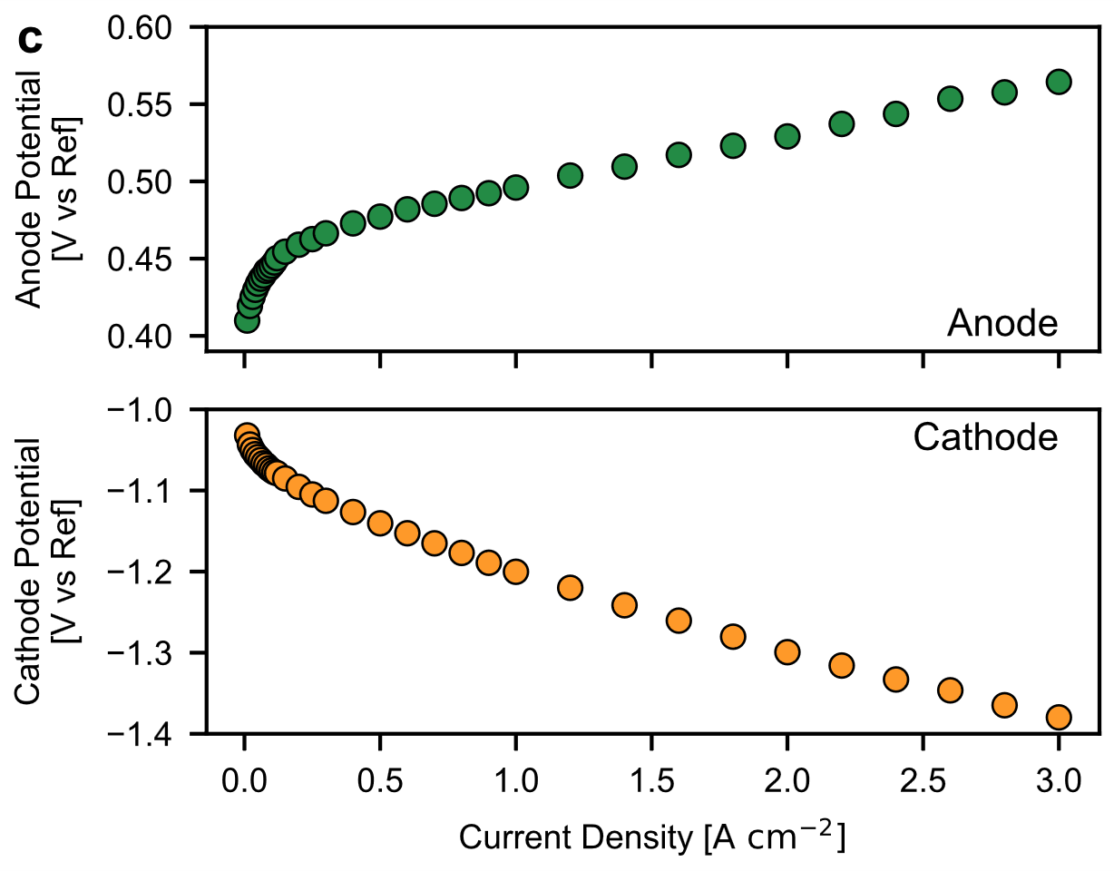 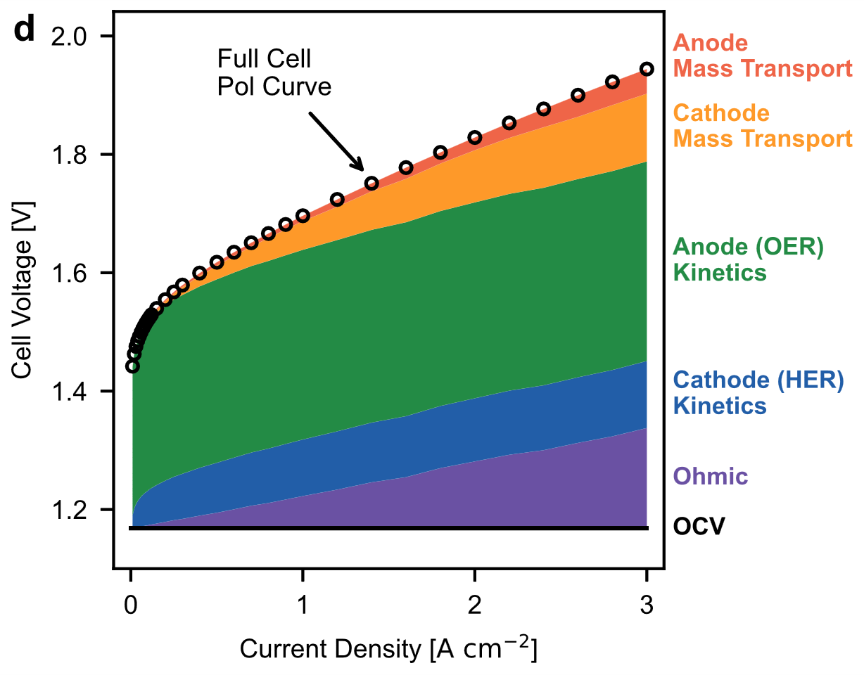  
**Figure 1.** a) Schematic of an AEMWE cell. b) Schematic of the MEA cell with an integrated Ag/AgCl reference electrode; additional description of the integrated refrence cell can be found in the supporting information. c) Polarization curves for the anode (top) and cathode (bottom). d) Applied-voltage breakdown of the AEMWE. 5 cm2 active area; 80°C; Anolyte: 1 M KOH; Catholyte: 1 M KOH; Anode PTE: 0.8 mgIrO2 cm‑2; Cathode GDE: 0.3 mgPt cm‑2 (Pt/C); 30 µm PiperionA AEM.

The applied-voltage breakdown from the three-electrode MEA experiment (Figure 1d) revealed two important characteristics of the AEMWE operation: i) though the cathode HER kinetics in alkaline media are considered to be magnitude slower than in acidic media,25 the anode OER kinetics loss still dominates overall cell kinetic loss, with 340 mV on the anode compared to 110 mV on the cathode at 3 A cm‑2. ii) In contrast to PEMWEs, where the mass-transport overpotential is dominated by the anode due to water consumption by OER and oxygen gas removal through the catalyst layer and PTLs,26 the AEMWE mass-transport overpotential mainly originates from the cathode side, likely due to the removal of hydrogen gas bubbles or the water supply.

*3.2. Electrode Design*

To understand how cathode GDE configuration can impact mass transport and cell performance, we investigated three critical properties: catalyst loading, microporous-layer (MPL) loading, and GDL hydrophobicity. The cell performance improves when increasing the catalyst loading from 0.15 to 0.3 mgPt cm‑2, while the cell performance remains almost unchanged when further increasing to 0.45 mgPt cm‑2 (Figure 2a), thereby indicating an optimal catalyst loading that balances electrode kinetics and mass transport (i.e., a too high loading provides more active sites but leads to higher diffusion barrier for gas product removal due to higher thickness). Adding an MPL to the GDL improves the kinetic performance of the cathode (Figure 2b – inlay) but shows only marginal influence at high current densities. Increasing the MPL loading from 0.5 to 1.0 mgC cm‑2 results in a small loss in performance. Similar to what has been reported for PEMWEs,26 adding a MPL creates a more intimate interface between the catalyst layer and the GDL, but overloading can result in too dense of a layer that hinders gas and liquid transport.27 Finally, the impact of GDL hydrophobicity on cell performance was studied by varying its polytetrafluoroethylene (PTFE) content. Similar to fuel cells,28 increasing GDL PTFE content helps prevent liquid-water accumulation and improves gas transport through the GDL. Preventing water accumulation, which reduces flooding in fuel cells, might impact cathode reactant water supply for AEMWEs and be detrimental, although improving gas transport can be beneficial for AEMWE performance by reducing resistance for the liquid water to reach the catalyst later. A large cell performance improvement is seen when the hydrophilic GDL (0 wt% PTFE) is switched to hydrophobic GDLs (5 and 10 wt% PTFE) as shown in Figure 2c. These results indicate that hydrogen bubble removal rather than water supply on the cathode impacts cell performance more, especially at high current density (>2 A cm‑2), where hydrogen gas bubble removal becomes critical.

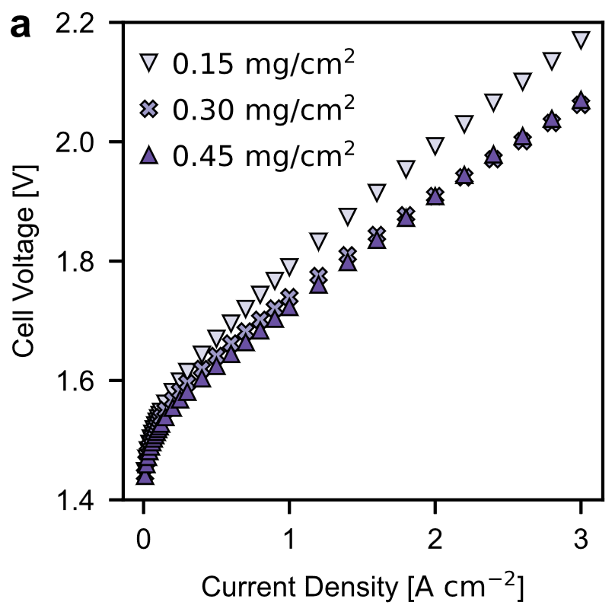 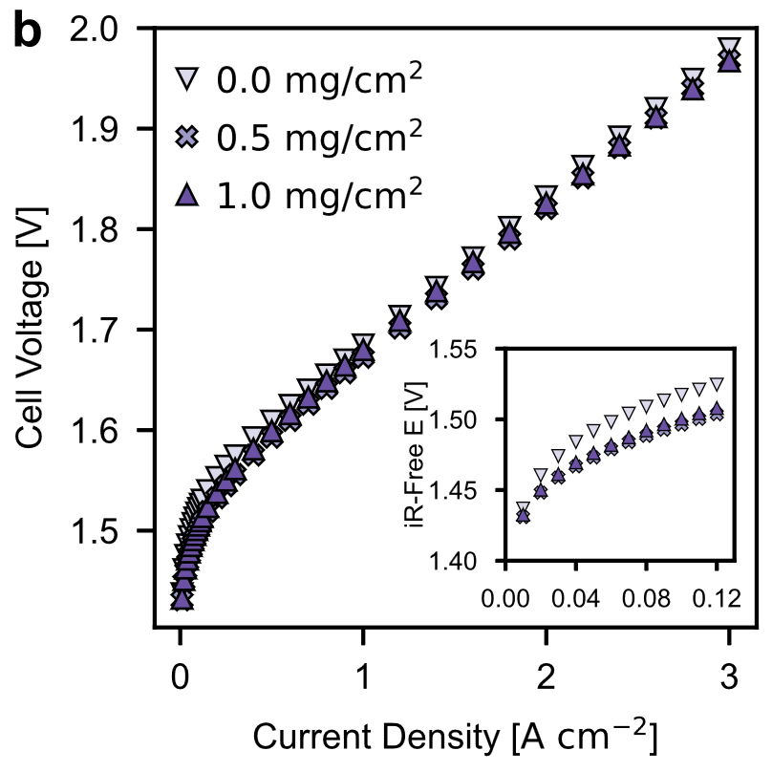 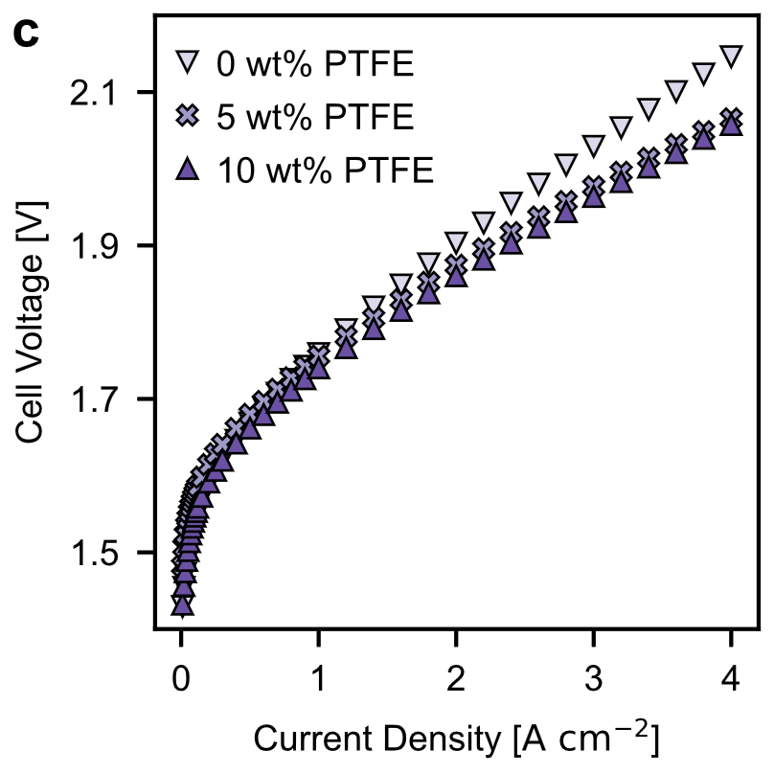  
**Figure 2.** Polarization curves when altering GDE fabrication parameters: (a) Pt loading (MPL: 0.5 mgC cm‑2, PTFE: 0 wt%, Anode: 0.8 mgIrO2 cm‑2); (b) MPL loading (0.3 mgPt cm‑2, PTFE: 0 wt%, Anode: 0.8 mgIrO2 cm‑2), Inset shows kinetic region; (c) PTFE content of the GDL (0.3 mgPt cm‑2, MPL: 0.5 mgC cm‑2Anode: 1.4 mgCo3O4 cm‑2). 5 cm2 active area; Anode feed: 1 M KOH; Cathode feed: 1 M KOH, 30 µm PiperionA AEM.

Previous research from our group indicates that electrochemical device performance is sensitive to catalyst-layer structure via impacting catalyst utilization and mass transport.29 To understand how anode structure can impact AEMWEs performance, we down select two widely used laboratory electrode coating methods.12 The catalyst-layer structure is expected to be more impactful on performance for non-PGM catalysts, which are generally less active compared to PGM catalysts and require higher catalyst loadings and therefore thicker electrodes. We first screened several commercially available OER catalysts (Figure S4). Co3O4 was found to have superior performance among others and even comparable performance to IrO2. The polarization curves for the Co3O4 porous transport electrodes (PTEs) fabricated using an airbrush and an ultrasonic spray coater are shown in Figure 2a. The airbrushed PTE reached a cell potential of 2 V at 3 A cm‑2, which was 260 mV lower than the cell potential with the ultrasonic spray coated PTE. SEM images of the PTEs showed that the airbrush produces a more porous catalyst layer (Figure 2b, 2c) with less cracks compared to the ultrasonic spray coated catalyst layer (Figure 2d, 2e).

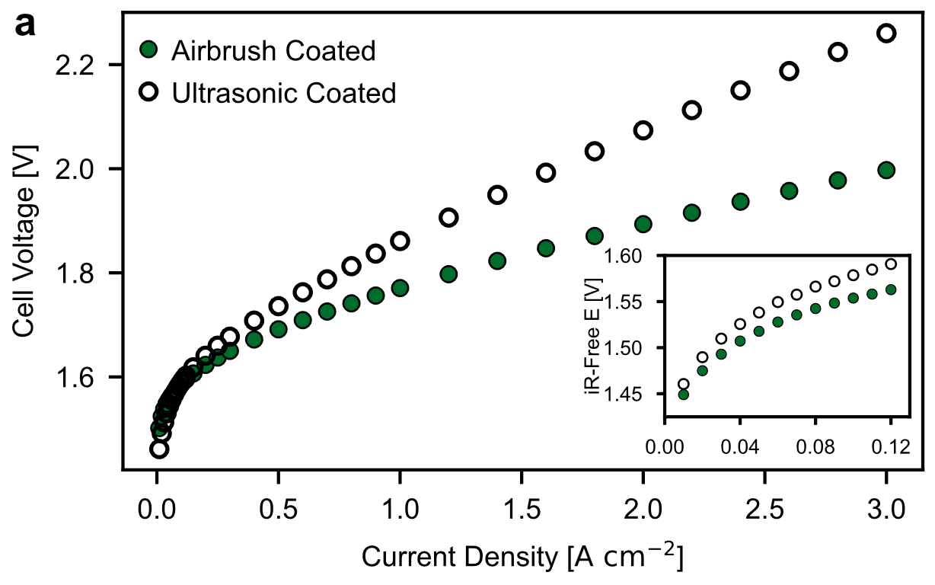  
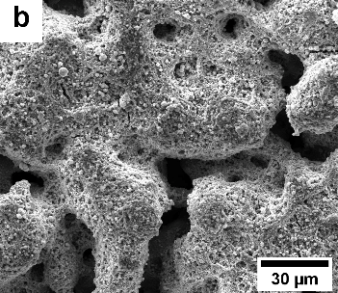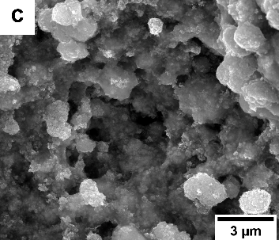

**Figure 3.** a) Polarization curve for Co3O4 PTEs fabricated using an airbrush (green, 2.0±0.2 mgCo3O4 cm-2) and an ultrasonic spray coater (hollow, 2.0±0.2 mgCo3O4 cm-2). Inset shows the kinetic region. 5 cm2 active area; 80°C; Anode Feed: 1 M KOH; Cathode Feed: 1 M KOH; Cathode GDE: 0.3 mgPt cm‑2 (Pt/C); 30 µm PiperionA AEM. SEM images of PTE fabricated using b-c) an airbrush and d-e) an ultrasonic spray coater.

A porous catalyst layer with less cracks leads to better catalyst accessibility possibly due to more uniform electrolyte infiltration. For this reason, the airbrush PTE had significantly better performance in the kinetic regime (Figure 3a – inset). SEM/EDS images (Figure S5) of the PTE cross-sections showed that catalyst particles penetrated into PTL for the ultrasonic coated PTE but not the airbrush coated PTE. As such, smaller pores of PTL could be blocked, which would impact gas transport and electrolyte supply, therefore impacting local ionic conductivity. Electrochemical-impedance measurements showed the ultrasonic spray coated PTE had much higher HFR (Figure S6), 107 mΩ cm2 compared to 59 mΩ cm2 at 3 A cm‑2, which accounts for approximately half of the potential difference between the two cells.

*3.3. Electrolyte Feed Configuration*

While dry cathode operation is preferable, AEM dry-out is possible at high current density30 and it is reasonable to expect a liquid feed to the cathode to improve performance. Here, the impact of feed configuration on the AEMWEs (Co3O4 anode and Pt/C cathode) performance, while feeding 1.0 M and 0.1 M KOH, was investigated (Figure 4a‑b). Among all cells operated with supporting electrolytes, cathode-dry operation results in improved performance over double-feed and anode-dry operations. While counterintuitive, these results indicate that water back-diffusion from the anode to the cathode can be a preferred pathway to supply water to the cathode compared to direct electrolyte feed even at a current density of 4 A cm-2. Comparison of the anode-dry and cathode-dry operation indicates overpotential induced by cathode hydrogen bubble transport is higher than that induced by anode oxygen bubble transport, due to twice the volumetric generation rate of hydrogen than oxygen at the same current density. Improved performance under cathode-dry operation compared to the other feed configurations was observed even when doubling the membrane thickness to 60 µm with 1.0 M KOH (Figure S8) and when using NiO as the OER catalyst feeding with 1.0 M KOH and 0.1 M KOH (Figure S9). Notably, others have reported lower performance under cathode-dry operation,30, 31 suggesting AEMs with high water diffusivity are preferred design to enable high-performing cathode-dry AEMWEs operation.

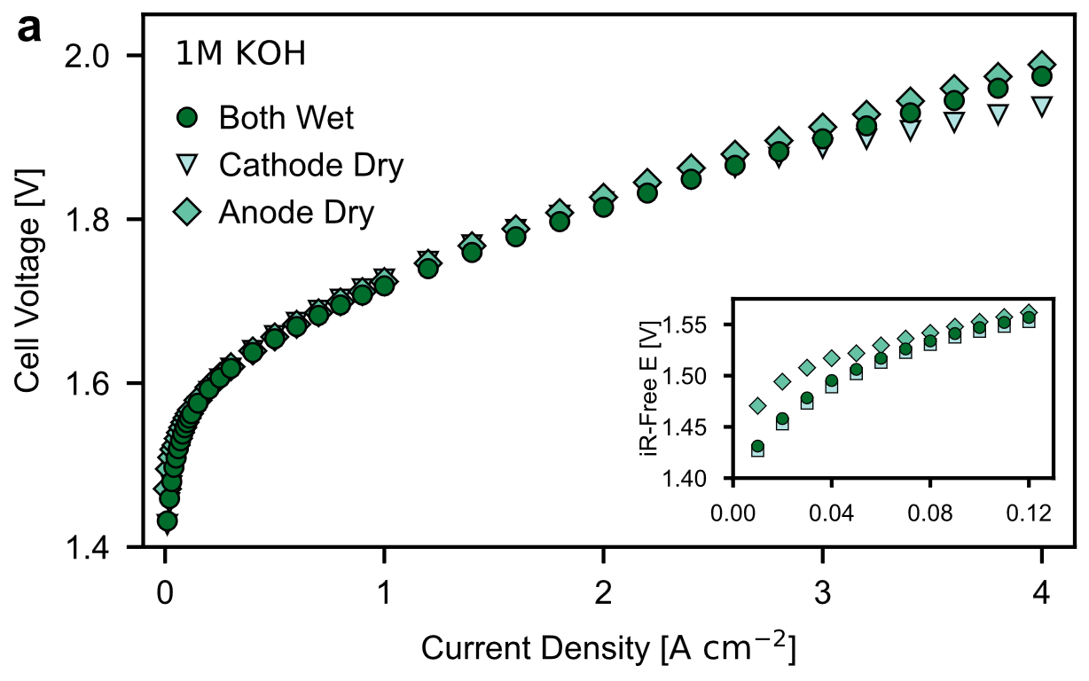 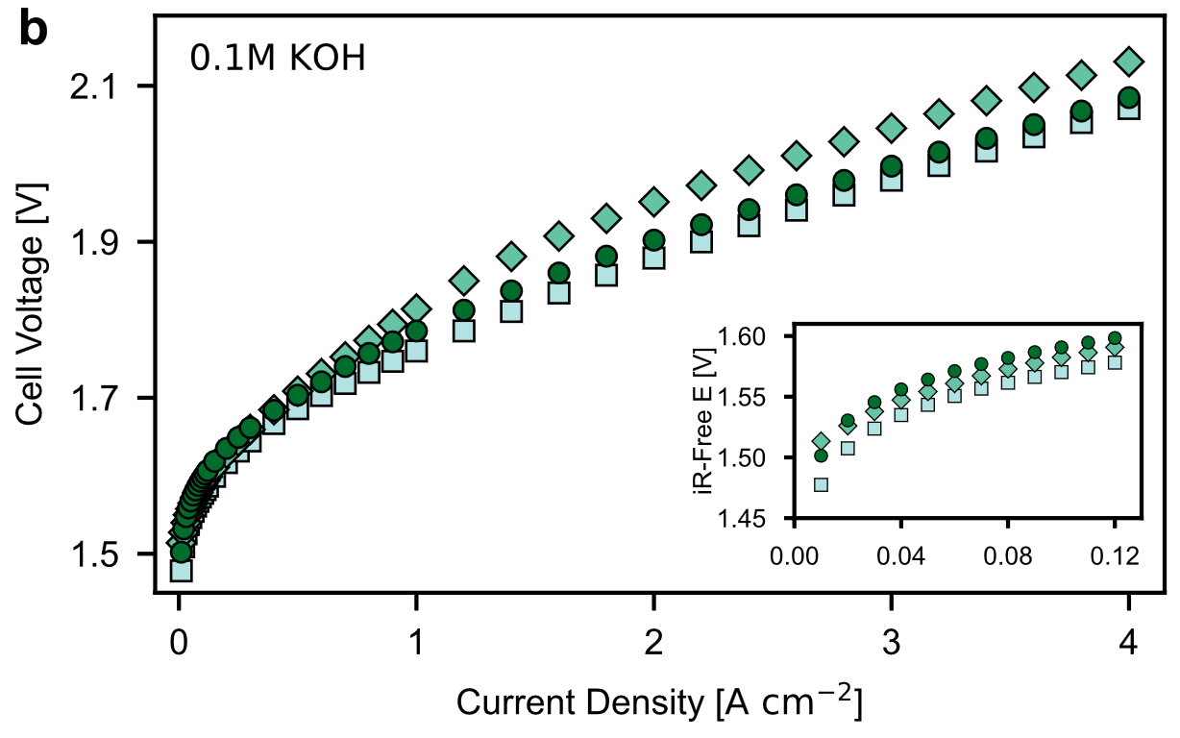 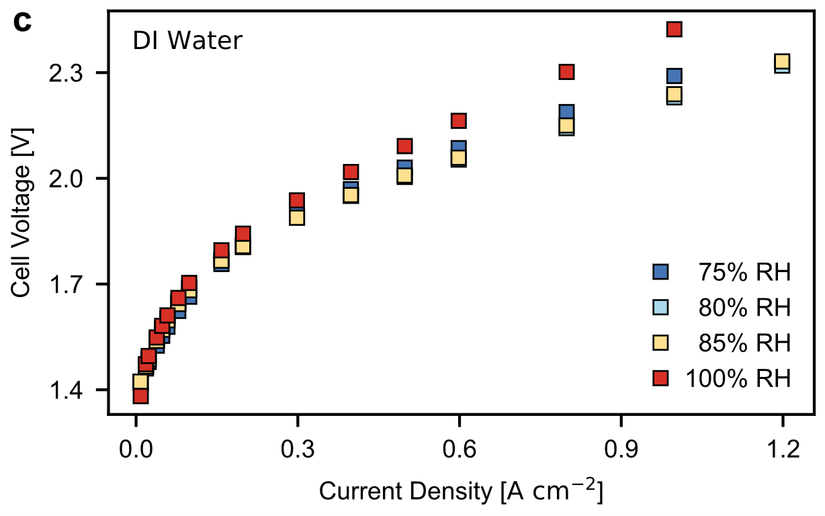 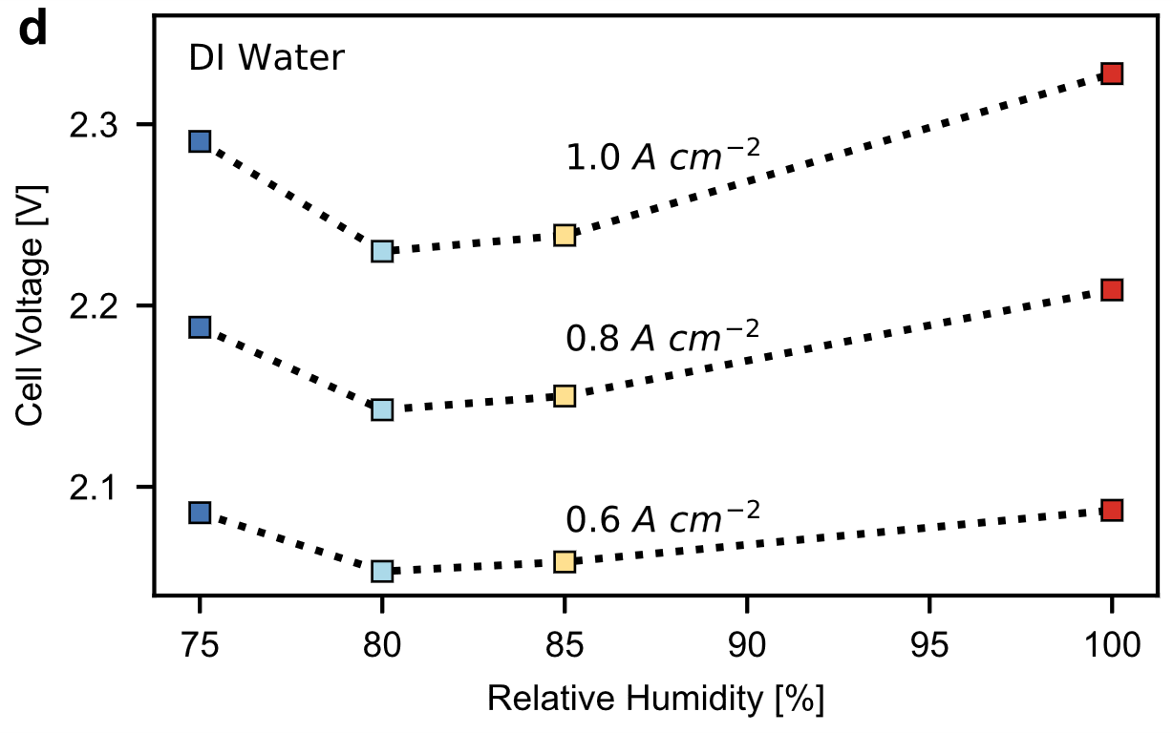   
**Figure 4.** Polarization curves of AEMWE cells with a Co3O4 (2.0±0.2 mgCo3O4 cm-2) anode comparing electrolyte feeds to both electrodes (●), anode-dry (♦), and cathode-dry (■) with a) 1 M KOH and b) 0.1 M KOH. c-d) Polarization curves with varying levels of relative humidity (RH) fed to the cathode (200 sccm H2) and DI water fed to the anode (0.8 mgIrO2 cm‑2). 5 cm2 active area; 80 °C; Cathode GDE: 0.3 mgPt cm‑2 (Pt/C); 30 µm PiperionA AEM.

To further illustrate how water back-diffusion can impact AEMWE performance even in DI-water feed condition, another set of studies was conducted by feeding DI water only to the anode side while flowing humidified H2 at 200 mL min‑1 to the cathode side at varying relative humidity (RH). PGM catalysts were purposefully chosen for both anode and cathode to minimize the catalyst degradation effects under DI water operating condition.32 It is worth noting that 200 mL min‑1 of H2 can sustain a pseudo reference electrode on the cathode side. Surprisingly, by simply manipulating the RH of the H2 fed to the cathode, the AEMWE performance varies. Polarization curves (Figure 4c) show that an optimal H2 feed RH exists, at around 80%, with the influence of RH being more prominent at higher current densities. The cell potential at current densities of 0.6, 0.8, and 1.0 A cm‑2 are plotted against the H2 feed RH to better highlight this trend (Figure 4d). A higher water gradient can be created between the anode and the cathode by decreasing RH from 100%, therefore facilitating water back-transport from anode to cathode,33 which is beneficial for improved performance. A reduced RH in the cathode can also remove condensed water on cathode GDL, therefore decreasing local hydrogen buildup in the catalyst layer. The cell performance decreases below 80% as the cathode probably begins to dry out, depriving the reaction of the necessary water and potentially hindering the conductivity of the ionomer. It should be noted that the ionomer water uptake can also play a role in impacting the AEMWE performance at different RH conditions as demonstrated by previous studies.15, 34 Overall, these results highlight the importance of water back-transport and point the direction of designing such AEMs for high-performing AEMWEs.

*3.4. Bicarbonate/Carbonate as Supporting Electrolytes*

We also investigated the influence of electrolyte identity, from KOH to more benign ones including HCO3-/CO32- electrolytes, on the impact of electrolyte feed configuration. A dramatic performance discrepancy is observed for various configurations of feeding with either 0.1 M K2CO3 or 0.1 M KHCO3 as the supporting electrolyte when using both Pt/C (Figure 5a‑b) and CoNiO2/C (Figure 5c‑d) as HER catalysts, which cannot be simply explained by the water dynamics among these feeding configurations as in the KOH cases. The significant performance difference is likely to be predominately caused by feeding HCO3-/CO32- to cathode if comparing cathode-dry with both-wet while a small portion comes from anode if comparing anode-dry with both-wet. The same trend was observed when feeding an electrolyte with a different cation (0.1M Na2CO3) (Figure S10). It is worth noting that the HFR (Figure S11a, S11b) follows a reverse trend of cathode-dry < both-wet < anode-dry as performance (Figure 5a, 5b) when Pt/C is used as catalyst for both K2CO3 and KHCO3 as electrolytes. Previous studies35, 36 have indicated that the proton donor of HER can come from not only H2O (Equation 4) but HCO3- (Equation 5) as well:

2 H2O + 2e- 🡪 2OH- + H2 E°= ‑0.828 V (4)

2HCO3- + 2e- 🡪 2CO32- + H2 E° = ‑0.612 V (5)

HCO3- + OH- 🡨🡪 CO32- + H2O (6)

However, the results showing that both HCO3- and CO32- impact cathode HER polarization behavior in a similar way indicates H2O is still the dominant proton donor. Additionally, HFR decreases for all feeds as current density increase (Figure S11), suggesting the carbonized AEMs are purged by OH- generated through HER, which further indicates the HER pathway mainly follows Equation 4. Rotating disk electrode (RDE) measurements have shown that HER currents increase with higher KHCO3concentrations,35, 36 indicating a promotional effect of KHCO3 solutions. This is the opposite trend observed here if comparing cathode-dry and both-wet, particularly at high current density region where RDE measurements cannot reach. This impact on kinetics is also observed in a larger charge transfer resistance comparing the both-wet to the cathode dry configuration (Figure S12). Therefore, we hypothesize that the negative impact on the cathode from HCO3-/CO32- comes from buffering the OH- generated by HER (Equation 6) inside the catalyst layer, leading to a large portion of the catalyst layer located far from the AEM being highly underutilized. Essentially, only a small portion of catalyst layer located very close to the AEM participates in HER to generate OH- that transfer through AEM to the anode for OER while also helping to maintain high alkalinity near the AEM region. Therefore, we observe in general a lower HFR in K2CO3 feed compared to KHCO3 feed (Figure S11a *vs.* S11b and Figure S11c *vs.* S11d) as HCO3- has a higher buffering capacity to OH- compared to CO32-. Additionally, the more active HER catalyst (Pt/C vs. CoNiO2/C) has lower HFR (Figure S11a *vs.* S11c and Figure S11b *vs.* S11d) since the more active HER catalyst requires less loading. The thinner catalyst layer, which is closer to the AEM, is less prone to the buffering effect by HCO3-/CO32-. Lastly, the buffering effect is also current dependent. High current density generates more OH‑, which helps extend the utilized catalyst layer zone farther from the membrane. This also explains the observation that a significant voltage loss is often seen at low current region (0 mA cm‑2 to ~200 mA cm‑2) whenever HCO3-/CO32- is fed to cathode. Feeding a pH equivalent concentration of KOH to the cathode (3 mM, 11.5 pH) while feeding 0.1 M K2CO3 to the anode resulted in similar performance as the cathode-dry configuration (Figure 5a), further supporting the hypothesis that the presence of HCO3‑/CO32‑ interferes with the cathode through the buffering effect.

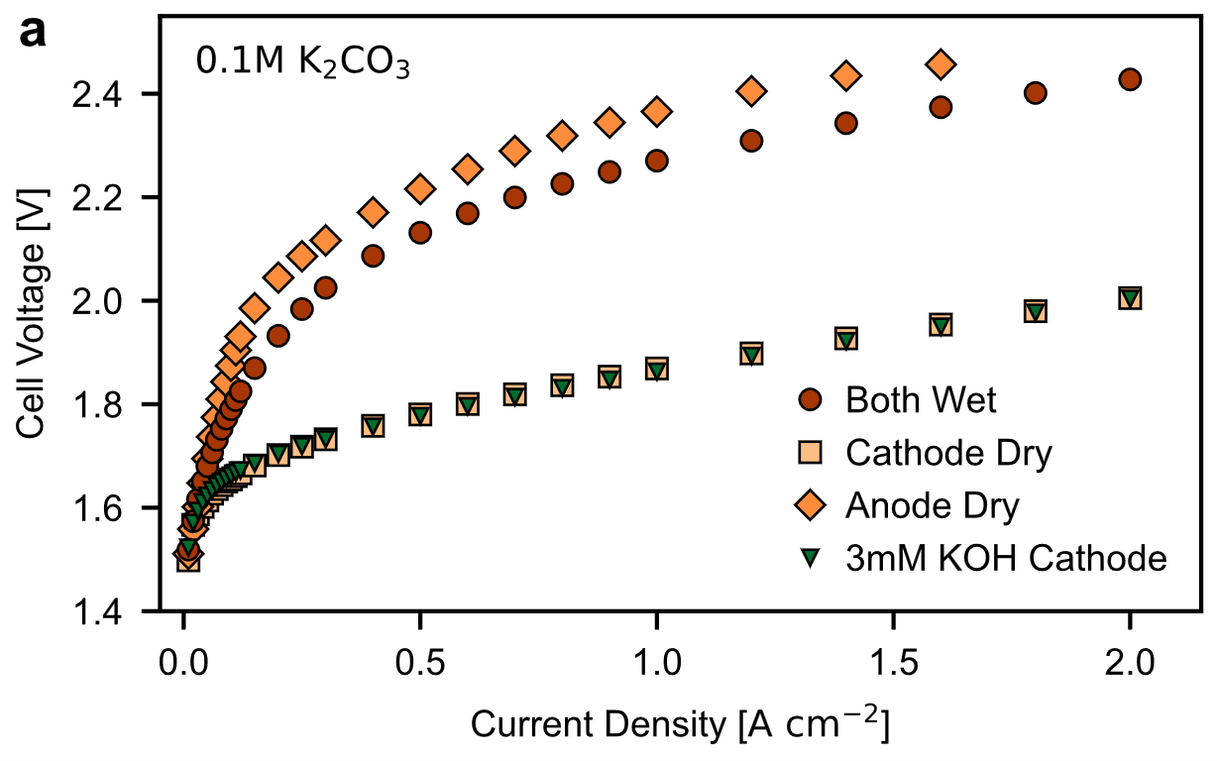 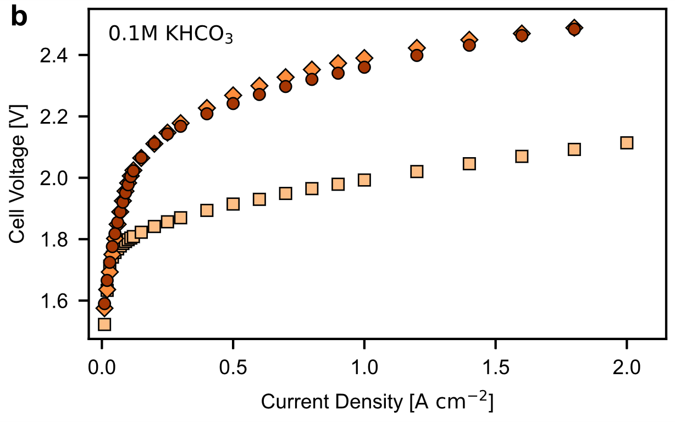   
 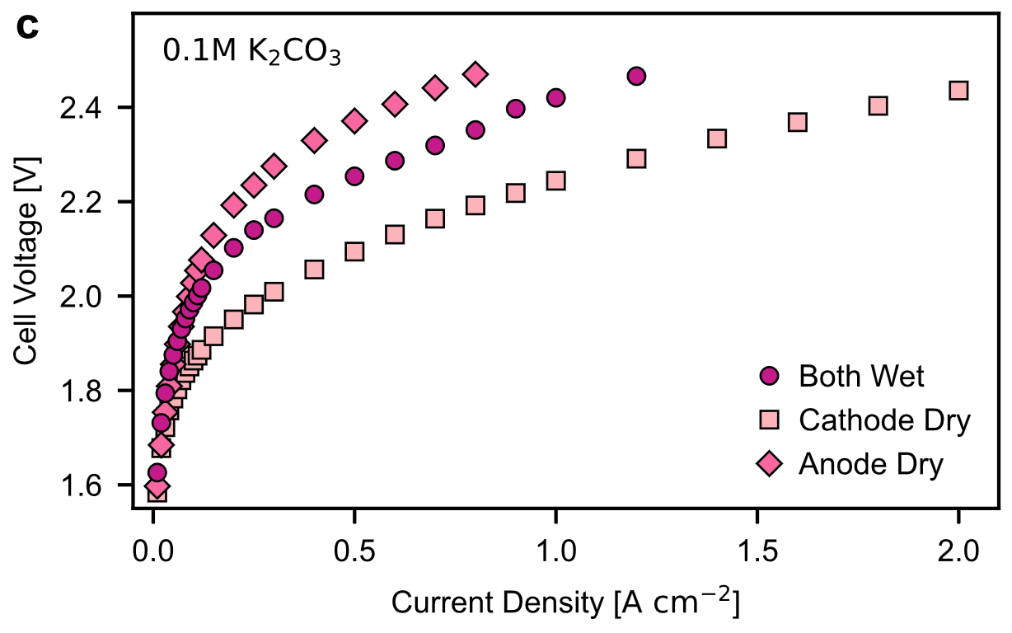 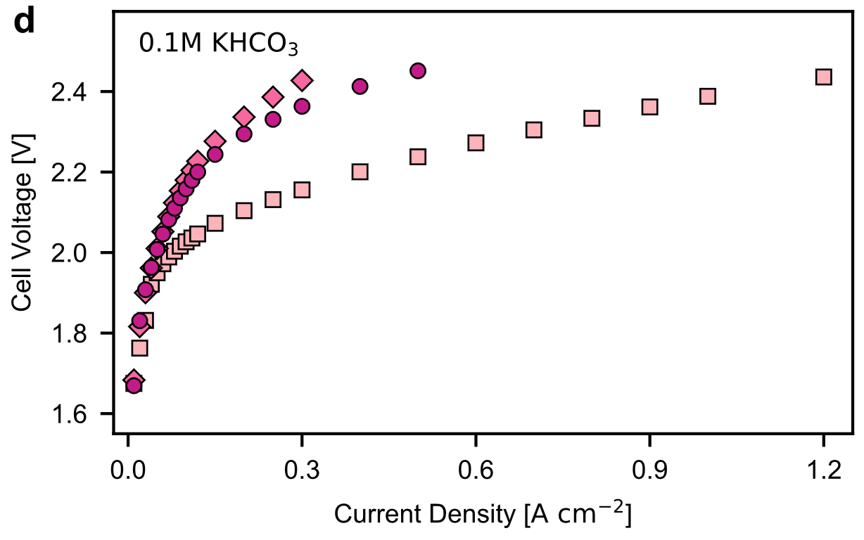  
**Figure 5.** Polarization curves of AEMWE cells with a Pt/C cathode (0.3 mgPt cm-2) comparing electrolyte feeds to both electrodes (●), anode-dry (♦), and cathode-dry (■) with a) 0.1 M KHCO3 and b) 0.1 M K2CO3. (▼) 3mM KOH feed to the cathode and 0.1 M K2CO3 feed to the anode. Polarization curves of AEMWE cells with a NiCo cathode (1.6 mgNiCo) comparing electrolyte feeds to both electrodes (●), anode-dry (♦), and cathode-dry (■) with a) 0.1 M KHCO3 and b) 0.1 M K2CO3. 5 cm2 active area; 80 °C; Anode PTE: 2.0±0.2 mgCo3O4 cm-2, 30 µm PiperionA AEM.

*3.5. PGM-free AEMWE Operation*

Finally, a complete PGM-free AEMWE was assembled and operated as guided by electrode design and operating principles from above. A similar Co3O4 anode electrode was coated on a stainless-steel fiber PTL (Figure S13). CoNiO2/C was selected as the non-PGM HER catalyst in place of Pt/C as mixed Ni-Co catalysts have been shown to have higher HER performance compared either just nickel or cobalt.37 The polarization curves were measured for the MEA with a dry cathode (cathode inlet dead-ended) while feeding 1 M KOH (Figure 6a) and 0.1 M KOH (Figure S14) to the anode. The PGM-free cell shows the capability of AEMWE running at high current densities (up to 4 A cm‑2) and at comparable efficiency to PEMWE with cathode-dry operation.38-40

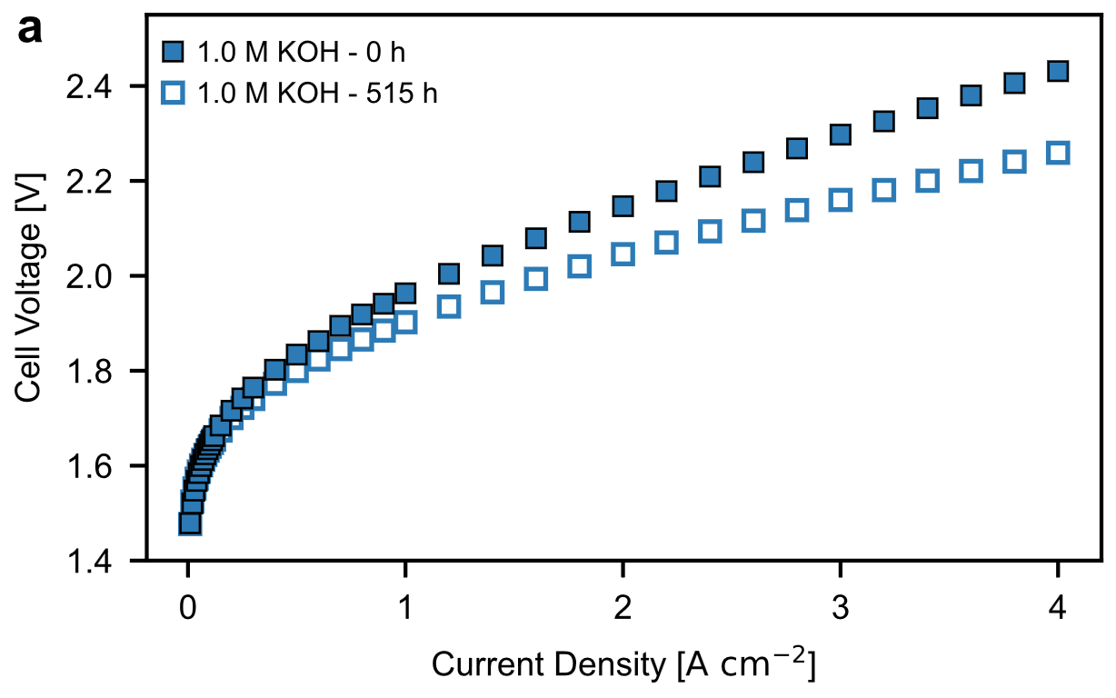 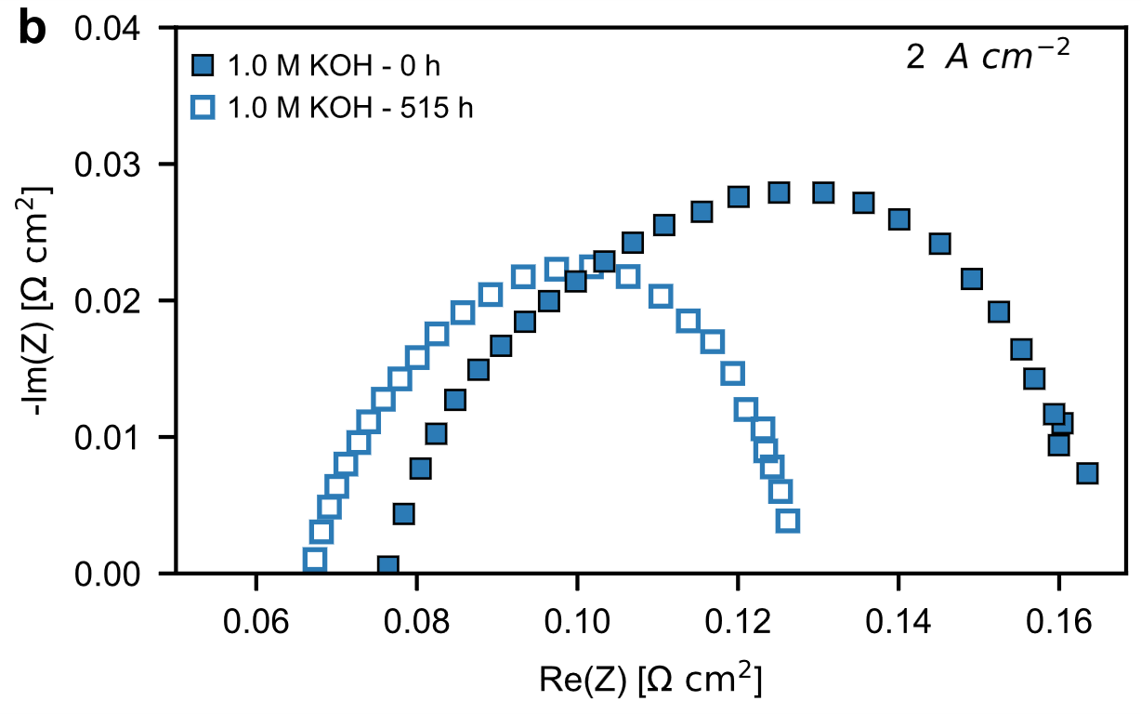  
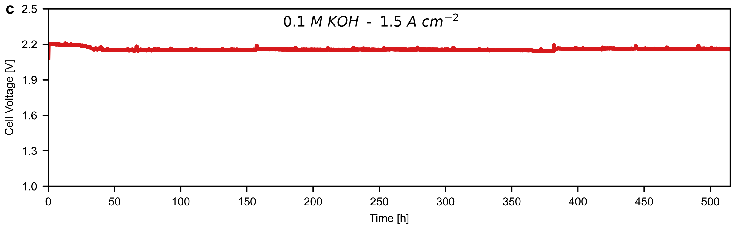  
**Figure 6.** a) Polarization curves for a complete PGM-free AEMWE in 1 M KOH at 0 h and after 515 h of operation. b) Nyquist plot for the fresh and after 515 h complete PGM-free AEMWE in 1 M KOH at 2 A cm‑2. c) Durability of the PGM-free AEMWE held at 1.5 A cm‑2 in 0.1 M KOH. 5 cm2 active area; 80°C; Cathode Feed: none; Anode PTE: 1.4 mgCo3O4 cm‑2, stainless-steel fiber PTL; Cathode GDE: 1.6 mgNiCo cm‑2; 30 µm PiperionA AEM.

The longevity test was conducted by holding the current at 1.5 A cm-2 with 0.1 M KOH solution recirculating only on anode side at rate of 25 mL min-1. The cell potential dropped from an initial value of 2.2 V to 2.15 V over the first 48 h of operation and exhibited negligible performance degradation afterwards up to 515 h (Figure 6c), ranking the one of the best-reported PGM-free AEMWE stability to date.17, 41-44 No extra KOH was added to the electrolyte during the test. The small voltage spikes were due to replenishing fresh water to the electrolyte bath, which led to temporary electrolyte temperature fluctuations. After the durability test, the performance improved as shown by the polarization curve comparison (Figure 6a). This is likely due to incomplete ion-exchange of the membrane and electrodes during cell assembly and complete ion-exchange to OH- during the current hold (likely happened after the first 48 h), as indicated by a drop in HFR (Figure 6b); similar behavior has been reported before.45 Additionally, the Nyquist plot shows the charge-transfer resistance was smaller in 1 M KOH after the 515 h, suggesting further activation of or better accessibility to the Co3O4 or CoNiO2/C catalysts. Overall, these results demonstrate that AEMWEs can be operated at high current density and dry-cathode condition supported by dilute electrolyte with negligible performance degradation.

**3. Conclusions**

In summary, a 3-electrode MEA diagnosis cell was used in conjunction with different electrode configurations to diagnose and optimize AEMWE performance. It was shown that anode-kinetic loss and cathode mass-transport loss dominate the overall AEMWE performance overpotential. The cathode mass-transport loss was ameliorated by systematically examining and optimizing the cathode structural properties including catalyst loading, MPL loading, and GDL hydrophobicity, where each exhibit optimal ranges. To mitigate the loss in the anode, a fabrication method that creates a more porous electrode is desired to help improve catalyst utilization and enhance electrode performance. Performance gains were universally observed using dry-cathode operation compared to dry-anode or both-wet, indicating the importance of water back-diffusion in AEM for KOH electrolyte and maintaining catalyst layer utilization for HCO3-/CO32- electrolytes. These learned design principles were used to assemble a complete PGM-free, high-performing (1.6 A cm‑2 at 2 V) AEMWE that exhibited exceptional durability (>515 h with negligible performance loss at 1.5 A cm‑2).

ASSOCIATED CONTENT

**Supporting Information**. HFR and Nyquist plots for AEMWE cells, additional polarization curves, and additional PTE/GDE characterization.

AUTHOR INFORMATION

Andrew W. Tricker: @AndrewWTricker

Jason K. Lee: @keonhag

ACKNOWLEDGMENT

The authors acknowledge the HydroGen Energy Materials Consortium from the Department of Energy, Hydrogen and Fuel Cell Technologies Office for financial support under Contract number DE-AC02-05CH11231. The views expressed in the article do not necessarily represent the views of the DOE or the U.S. Government.

CONFLICT OF INTEREST

The authors declare no conflict of interest.

REFERENCES

(1) Cullen, D. A.; Neyerlin, K.; Ahluwalia, R. K.; Mukundan, R.; More, K. L.; Borup, R. L.; Weber, A. Z.; Myers, D. J.; Kusoglu, A. New roads and challenges for fuel cells in heavy-duty transportation. *Nat. Energy* **2021**, *6* (5), 462-474. DOI: 10.1038/s41560-021-00775-z

(2) Pee, A. d.; Pinner, D.; Roelofsen, O.; Somers, K. *Decarbonization of Industrial Sectors: The Next Frontier*; McKinsey & Company, 2018.

(3) *Global Hydrogen Review 2021*; IEA, 2021.

(4) Millet, P.; Grigoriev, S. Water Electrolysis Technologies. In *Renewable Hydrogen Technologies: Production, Purification, Storage, Applications and Safety*, Gandia, L. M., Arzamendi, G., Dieguez, P. M. Eds.; 2013; pp 19-41.

(5) Ahmed, K. W.; Jang, M. J.; Park, M. G.; Chen, Z.; Fowler, M. Effect of Components and Operating Conditions on the Performance of PEM Electrolyzers: A Review. *Electrochem* **2022**, *3* (4), 581-612. DOI: 10.3390/electrochem3040040

(6) Awasthi, A.; Scott, K.; Basu, S. Dynamic modeling and simulation of a proton exchange membrane electrolyzer for hydrogen production. *Int. J. Hydrog. Energy* **2011**, *36* (22), 14779-14786. DOI: 10.1016/j.ijhydene.2011.03.045

(7) Taie, Z.; Peng, X.; Kulkarni, D.; Zenyuk, I. V.; Weber, A. Z.; Hagen, C.; Danilovic, N. Pathway to complete energy sector decarbonization with available iridium resources using ultralow loaded water electrolyzers. *ACS Appl. Mater. Interfaces* **2020**, *12* (47), 52701-52712.

(8) *Hydrogen for Net Zero: A Critical Cost-competitive Energy Vector*; The Hydrogen Council, McKinsey & Compnay, 2021.

(9) *Hydrogen Shot*. Hydrogen and Fuel Cell Technologies Office, U.S. Department of Energy, <https://www.energy.gov/eere/fuelcells/hydrogen-shot> (accessed October 29, 2022).

(10) Du, N.; Roy, C.; Peach, R.; Turnbull, M.; Thiele, S.; Bock, C. Anion-Exchange Membrane Water Electrolyzers. *Chem. Rev.* **2022**, *122* (13), 11830-11895. DOI: 10.1021/acs.chemrev.1c00854

(11) Chatenet, M.; Pollet, B. G.; Dekel, D. R.; Dionigi, F.; Deseure, J.; Millet, P.; Braatz, R. D.; Bazant, M. Z.; Eikerling, M.; Staffell, I. Water electrolysis: from textbook knowledge to the latest scientific strategies and industrial developments. *Chem. Soc. Rev.* **2022**, *51* (11), 4583-4762. DOI: 10.1039/d0cs01079k

(12) Xu, Q.; Zhang, L.; Zhang, J.; Wang, J.; Hu, Y.; Jiang, H.; Li, C. Anion Exchange Membrane Water Electrolyzer: Electrode Design, Lab-Scaled Testing System and Performance Evaluation. *EnergyChem* **2022**, *4* (5), 100087. DOI: 10.1016/j.enchem.2022.100087

(13) Li, D.; Motz, A. R.; Bae, C.; Fujimoto, C.; Yang, G.; Zhang, F.-Y.; Ayers, K. E.; Kim, Y. S. Durability of anion exchange membrane water electrolyzers. *Energy Environ. Sci.* **2021**, *14* (6), 3393-3419. DOI: 10.1039/D0EE04086J

(14) Mandal, M. Recent advancement on anion exchange membranes for fuel cell and water electrolysis. *ChemElectroChem* **2021**, *8* (1), 36-45. DOI: 10.1002/celc.202001329

(15) Huang, G.; Mandal, M.; Hassan, N. U.; Groenhout, K.; Dobbs, A.; Mustain, W. E.; Kohl, P. A. Ionomer optimization for water uptake and swelling in anion exchange membrane electrolyzer: hydrogen evolution electrode. *J. Electrochem. Soc.* **2021**, *168* (2), 024503. DOI: 10.1149/1945-7111/abde7b

(16) Li, D.; Park, E. J.; Zhu, W.; Shi, Q.; Zhou, Y.; Tian, H.; Lin, Y.; Serov, A.; Zulevi, B.; Baca, E. D. Highly quaternized polystyrene ionomers for high performance anion exchange membrane water electrolysers. *Nat. Energy* **2020**, *5* (5), 378-385. DOI: 10.1038/s41560-020-0577-x

(17) Chen, P.; Hu, X. High‐Efficiency Anion Exchange Membrane Water Electrolysis Employing Non‐Noble Metal Catalysts. *Adv. Energy. Mater.* **2020**, *10* (39), 2002285. DOI: 10.1002/aenm.202002285

(18) Klingenhof, M.; Hauke, P.; Kroschel, M.; Wang, X.; Merzdorf, T.; Binninger, C.; Ngo Thanh, T.; Paul, B.; Teschner, D.; Schlögl, R. Anion-Tuned Layered Double Hydroxide Anodes for Anion Exchange Membrane Water Electrolyzers: From Catalyst Screening to Single-Cell Performance. *ACS Energy Lett.* **2022**, *7*, 3415-3422. DOI: 10.1021/acsenergylett.2c01820

(19) Bates, R. G.; Bower, V. E. Standard potential of the silver-silver-chloride electrode from 0 to 95C and the thermodynamic properties of dilute hydrochloric acid solutions. *Journal of Research of the National Bureau of Standards* **1954**, *53* (5), 283-290. DOI: 10.6028/jres.053.037

(20) Bratsch, S. G. Standard electrode potentials and temperature coefficients in water at 298.15 K. *J. Phys. Chem. Ref. Data* **1989**, *18* (1), 1-21. DOI: 10.1063/1.555839

(21) Roy, A. L.; Peng, J.; Zawodzinski, T. A. Determining electro-osmotic drag of water in anion exchange membrane Fuel Cells. In *ECS Meeting Abstracts*, 2018; IOP Publishing: p 1755.

(22) Yan, Q.; Toghiani, H.; Wu, J. Investigation of water transport through membrane in a PEM fuel cell by water balance experiments. *J. Power Sources* **2006**, *158* (1), 316-325. DOI: 10.1016/j.jpowsour.2005.09.013

(23) Liu, J.; Kang, Z.; Li, D.; Pak, M.; Alia, S. M.; Fujimoto, C.; Bender, G.; Kim, Y. S.; Weber, A. Z. Elucidating the role of hydroxide electrolyte on anion-exchange-membrane water electrolyzer performance. *J. Electrochem. Soc.* **2021**, *168* (5), 054522.

(24) Xu, Q.; Oener, S. Z.; Lindquist, G.; Jiang, H.; Li, C.; Boettcher, S. W. Integrated reference electrodes in anion-exchange-membrane electrolyzers: impact of stainless-steel gas-diffusion layers and internal mechanical pressure. *ACS Energy Lett.* **2020**, *6* (2), 305-312. DOI: 10.1021/acsenergylett.0c02338

(25) Durst, J.; Siebel, A.; Simon, C.; Hasché, F.; Herranz, J.; Gasteiger, H. New insights into the electrochemical hydrogen oxidation and evolution reaction mechanism. *Energy Environ. Sci.* **2014**, *7* (7), 2255-2260. DOI: 10.1039/c4ee00440j

(26) Peng, X.; Satjaritanun, P.; Taie, Z.; Wiles, L.; Keane, A.; Capuano, C.; Zenyuk, I. V.; Danilovic, N. Insights into Interfacial and Bulk Transport Phenomena Affecting Proton Exchange Membrane Water Electrolyzer Performance at Ultra‐Low Iridium Loadings. *Adv. Sci.* **2021**, *8* (21), 2102950. DOI: 10.1002/advs.202102950

(27) Gostick, J. T.; Gunterman, H.; Kienitz, B.; Newman, J.; MacDowell, A.; Weber, A. Tomographic imaging of water injection and withdrawal in PEMFC gas diffusion layers. *ECS Trans.* **2010**, *33* (1), 1407.

(28) Peng, X.; Kulkarni, D.; Huang, Y.; Omasta, T. J.; Ng, B.; Zheng, Y.; Wang, L.; LaManna, J. M.; Hussey, D. S.; Varcoe, J. R. Using operando techniques to understand and design high performance and stable alkaline membrane fuel cells. *Nat. Commun.* **2020**, *11* (1), 1-10. DOI: 10.1038/s41467-020-17370-7

(29) Peng, X.; Taie, Z.; Liu, J.; Zhang, Y.; Peng, X.; Regmi, Y. N.; Fornaciari, J. C.; Capuano, C.; Binny, D.; Kariuki, N. N. Hierarchical electrode design of highly efficient and stable unitized regenerative fuel cells (URFCs) for long-term energy storage. *Energy Environ. Sci.* **2020**, *13* (12), 4872-4881. DOI: 10.1039/d0ee03244a

(30) Koch, S.; Disch, J.; Kilian, S. K.; Han, Y.; Metzler, L.; Tengattini, A.; Helfen, L.; Schulz, M.; Breitwieser, M.; Vierrath, S. Water management in anion-exchange membrane water electrolyzers under dry cathode operation. *RSC Adv.* **2022**, *12* (32), 20778-20784. DOI: 10.1039/d2ra03846c

(31) Kiessling, A.; Fornaciari, J. C.; Anderson, G.; Peng, X.; Gerstmayr, A.; Gerhardt, M.; McKinney, S.; Serov, A.; Weber, A. Z.; Kim, Y. S. Influence of Supporting Electrolyte on Hydroxide Exchange Membrane Water Electrolysis Performance: Catholyte. *J. Electrochem. Soc.* **2022**, *169* (2), 024510. DOI: 10.1149/1945-7111/ac4fed

(32) Krivina, R. A.; Lindquist, G. A.; Beaudoin, S. R.; Stovall, T. N.; Thompson, W. L.; Twight, L. P.; Marsh, D.; Grzyb, J.; Fabrizio, K.; Hutchison, J. E. Anode Catalysts in Anion‐Exchange‐Membrane Electrolysis without Supporting Electrolyte: Conductivity, Dynamics, and Ionomer Degradation. *Adv. Mater.* **2022**, *34* (35), 2203033. DOI: 10.1002/adma.202203033

(33) Liu, J.; Weber, A. Z. Ionomer Optimization for Hydroxide-Exchange-Membrane Water Electrolyzers Operated with Distilled Water: A Modeling Study. *J. Electrochem. Soc.* **2022**, *169* (5), 054506. DOI: 10.1149/1945-7111/ac69c4

(34) Chen, M.; Mandal, M.; Groenhout, K.; McCool, G.; Tee, H. M.; Zulevi, B.; Kohl, P. A. Self-adhesive ionomers for durable low-temperature anion exchange membrane electrolysis. *J. Power Sources* **2022**, *536*, 231495. DOI: 10.1016/j.jpowsour.2022.231495

(35) Marcandalli, G.; Boterman, K.; Koper, M. T. Understanding hydrogen evolution reaction in bicarbonate buffer. *J. Catal.* **2022**, *405*, 346-354. DOI: 10.1016/j.jcat.2021.12.012

(36) Marcandalli, G.; Goyal, A.; Koper, M. T. Electrolyte effects on the faradaic efficiency of CO2 reduction to CO on a gold electrode. *ACS Catal.* **2021**, *11* (9), 4936-4945. DOI: 10.1021/acscatal.1c00272

(37) Faid, A. Y.; Barnett, A. O.; Seland, F.; Sunde, S. Optimized nickel-cobalt and nickel-iron oxide catalysts for the hydrogen evolution reaction in alkaline water electrolysis. *J. Electrochem. Soc.* **2019**, *166* (8), F519. DOI: 10.1149/2.0821908jes

(38) Hegge, F.; Lombeck, F.; Cruz Ortiz, E.; Bohn, L.; von Holst, M.; Kroschel, M.; Hübner, J.; Breitwieser, M.; Strasser, P.; Vierrath, S. Efficient and stable low iridium loaded anodes for PEM water electrolysis made possible by nanofiber interlayers. *ACS Appl. Energy Mater.* **2020**, *3* (9), 8276-8284. DOI: 10.1021/acsaem.0c00735

(39) Holzapfel, P. K.; Bühler, M.; Escalera‐López, D.; Bierling, M.; Speck, F. D.; Mayrhofer, K. J.; Cherevko, S.; Pham, C. V.; Thiele, S. Fabrication of a Robust PEM Water Electrolyzer Based on Non‐Noble Metal Cathode Catalyst:[Mo3S13] 2− Clusters Anchored to N‐Doped Carbon Nanotubes. *Small* **2020**, *16* (37), 2003161. DOI: 10.1002/smll.202003161

(40) Wu, Z.-Y.; Chen, F.-Y.; Li, B.; Yu, S.-W.; Finfrock, Y. Z.; Meira, D. M.; Yan, Q.-Q.; Zhu, P.; Chen, M.-X.; Song, T.-W. Non-iridium-based electrocatalyst for durable acidic oxygen evolution reaction in proton exchange membrane water electrolysis. *Nat. Mater.* **2022**, 1-9. DOI: 10.1038/s41563-022-01380-5

(41) Park, Y. S.; Jeong, J.; Noh, Y.; Jang, M. J.; Lee, J.; Lee, K. H.; Lim, D. C.; Seo, M. H.; Kim, W. B.; Yang, J. Commercial anion exchange membrane water electrolyzer stack through non-precious metal electrocatalysts. *Appl. Catal., B* **2021**, *292*, 120170. DOI: 10.1016/j.apcatb.2021.120170

(42) Liu, Z.; Sajjad, S. D.; Gao, Y.; Yang, H.; Kaczur, J. J.; Masel, R. I. The effect of membrane on an alkaline water electrolyzer. *Int. J. Hydrog. Energy* **2017**, *42* (50), 29661-29665. DOI: 10.1016/j.ijhydene.2017.10.050

(43) Wang, L.; Weissbach, T.; Reissner, R.; Ansar, A.; Gago, A. S.; Holdcroft, S.; Friedrich, K. A. High performance anion exchange membrane electrolysis using plasma-sprayed, non-precious-metal electrodes. *ACS Appl. Energy Mater.* **2019**, *2* (11), 7903-7912. DOI: 10.1021/acsaem.9b01392

(44) Ďurovič, M.; Hnát, J.; Bernäcker, C. I.; Rauscher, T.; Röntzsch, L.; Paidar, M.; Bouzek, K. Nanocrystalline Fe60Co20Si10B10 as a cathode catalyst for alkaline water electrolysis: Impact of surface activation. *Electrochim. Acta* **2019**, *306*, 688-697. DOI: 10.1016/j.electacta.2019.03.107

(45) Hassan, N. U.; Mandal, M.; Zulevi, B.; Kohl, P. A.; Mustain, W. E. Understanding and improving anode performance in an alkaline membrane electrolyzer using statistical design of experiments. *Electrochim. Acta* **2022**, *409*, 140001. DOI: 10.1016/j.electacta.2022.140001